Medical Summary – <Name of Patient>
Instructions on Last Page
(Delete this notice before printing)
Last updated on: <Insert Date>

NOTICE: This file contains sensitive medical information and must only be shared with trusted medical personnel handling the care of this patient
The contents of this file may not be copied without the permission of this patient.

Critical Information
- <Insert any critical information here>

Photo of Patient

Metadata
- Version: 1.1
- URL: <insert link to soft copy of file>
- Author: <Insert your name>
QR Code to this file:
<NOTE: Replace with your own file’s QR>

Conditions
Condition | Doctor | Timeline | Details
Surgeries
Surgery | Doctor | Timeline | Details
Other Notable Incidents and Issues
Incident | Doctor | Timeline | Details

Present medication
Type | Medication | Schedule
Critical |  | <Eg- 1-0-1, or SOS>
Routine
Supplementary

Allergies
Allergy | Solution

Vaccines
Vaccine | Date

Medical Devices
Device | Details

Disability / Accessibility Requirements
Vaccine | Date

Notes
- <Anything else you’d like a medical practitioner to know that isn’t already specified above?>

Personal Information
- Full Name: <Insert Full Name>
- Date of Birth: <Insert Date of Birth, Eg: 1 April, 1987>
- Blood Group: <Insert Blood Group>
- Height: <Insert Height>
- Weight: <Insert Weight>
- Primary Address: <Insert address>
- Primary Doctor: <Insert Doctor’s name, contact details and practice address>
- Communication Languages: <Insert languages that the patient is comfortable communicating in>
Insurance
Insurer | Details

Caregiver contacts:
- <Insert name and contact details of caregivers and other emergency contacts>
Chronological Medical History
- <Date>: <Issue>

Instructions
- Fill out a separate file for each person. Do not add details of multiple people in a single file.
- Print and insert into a visibly distinct file. Keep copies at the patient’s residence in an easy to access location (such as in their medical supplies cabinet, medical bag and/or travel kit).
- This should not be stored in a hidden or locked location- it needs be easy to retrieve during a medical emergency.
- In the file, add copies of any recent and important diagnostic tests.
- Additionally add any additional important paperwork to the same file, such as a DNR (no not resuscitate) or advance directive.
- Prefer typing the details into this file over hand writing for legibility.
- For sections that are empty, clarify whether the information is known or not. For example, if you know that the patient is not on medication, then specify “Not on medication”, but if you do not know what medication the patient is on, then specify “Not known”.
- Before printing:
  - Disable markup. If you don’t, your printouts will include all the comments visible on the right side of the document.
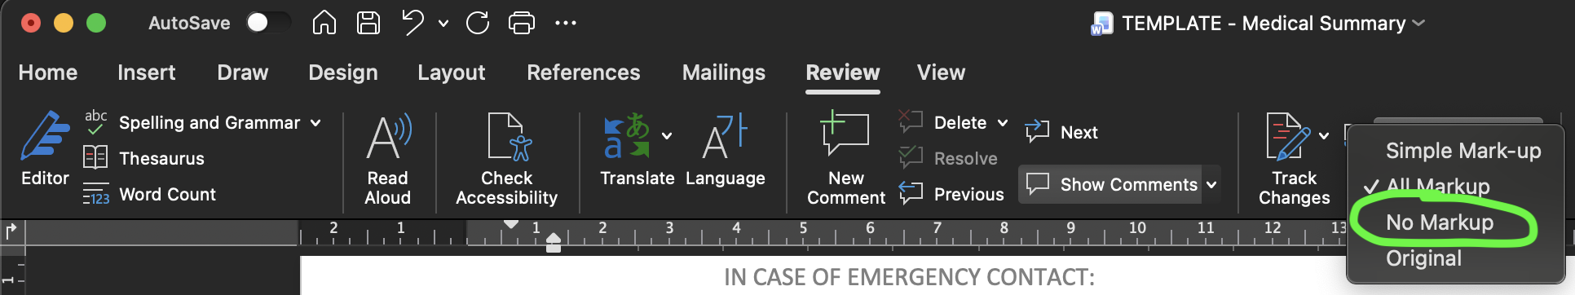
  - Delete this page.
Tips
- When updating this file, update the name of the file as well. Include the date in the file name for ease of access. Specify “LATEST” in the file name for the current version (and delete “LATEST” from the previous version). Eg: MedicalSummary_JohnDoe_2025-ARPIL-01_LATEST.docx.
- Maintain a copy of this file in the patient’s phone (and the phone of trusted care givers and family members).
- Add a calendar event / reminder to remind yourself to update this file every 3 to 6 months.
- Inform family members, caregivers and neighbours about the location of this file.
Meta
- If you’d like to provide feedback about this template, suggestions on how to improve this, criticisms (especially if you’re a doctor), please feel free to email Aditya@Sengupta.me, the original author of this template.
- This template is provided under the Creative Commons BY-SA 4.0 license.

